Case Study Report



**Tech Saksham**

Data Analytics with Power BI

**“Inventory and sales analysis of Departmental Store”**

**“Nilgiri College of Arts and Science”**

|  |  |
| --- | --- |
| **NM ID** | **NAME** |
| ABA98E1E0C242F4AE0E4C32D478E5372 | Mohammed Adnan |

|  |  |
| --- | --- |
|  |  |
|  | Trainer Name : R UMAMAHESWARI |
|  | Master Trainer : R UMAMAHESWARI |

**ABSTRACT**

In the competitive retail landscape, data-driven insights are crucial for success. This project leverages Power BI, a powerful business intelligence tool, to analyse a departmental store's inventory and sales data. By visualizing key metrics like sales trends, year-over-year performance, and departmental/product performance, the project aims to empower store managers. These insights will guide strategic decision-making in areas like inventory management, product selection, and pricing strategies. Ultimately, this data-driven approach will help optimize store operations and drive improved sales performance.

**INDEX**

|  |  |  |
| --- | --- | --- |
| **Sr. No.** | **Table of Contents** | **Page No.** |
| 1 | Chapter 1: Introduction | 4 |
| 2 | Chapter 2: Services and Tools Required | 6 |
| 3 | Chapter 3: Project Architecture | 7 |
| 4 | Chapter 4: Modeling and Result | 9 |
| 5 | Conclusion | 18 |
| 6 | Future Scope | 19 |
| 7 | References | 20 |
| 8 | Links | 21 |

**CHAPTER 1**

**INTRODUCTION**

* 1. **Problem Statement**

Traditional retail relies on intuition and experience to manage inventory and sales. This can lead to missed opportunities and inefficiencies. Departmental stores struggle to identify buying trends, optimize product selection across departments, and tailor pricing strategies for maximum profitability. Without data-driven insights, it's difficult to understand customer behavior and preferences, which can hinder efforts to improve customer satisfaction and loyalty. This project aims to bridge this gap by leveraging Power BI to analyze sales data and unlock valuable insights for departmental store optimization.

* 1. **Proposed Solution**

The proposed system tackles the challenges of traditional departmental store management by implementing a data-driven approach powered by Power BI. This business intelligence tool will act as a central hub, ingesting sales and inventory data. Power BI's analytical muscle will then be unleashed to identify trends, compare year-over-year performance, and evaluate product and departmental effectiveness. The system will present these insights through interactive dashboards and reports, providing store managers with a clear picture of their sales landscape. This data-rich environment will empower them to optimize inventory levels, make informed decisions about product selection and pricing, and ultimately, drive departmental sales and profitability.

* 1. **Feature**
* **Inventory Management:** Ability to track inventory levels, identify slow-moving or out-of-stock items, and optimize stock based on sales trends.
* **Sales Trend Analysis:** Visualization of sales data over time to identify seasonal trends, popular product categories, and buying patterns.
* **Year-over-Year Performance Comparison:** Comparison of current sales figures with historical data to measure growth or decline and identify areas for improvement.
* **Departmental Performance Analysis:** Analysis of sales data by department to understand departmental contribution to overall sales and profitability.
* **Product Performance Evaluation:** Evaluation of individual product sales performance to identify top sellers, lags, and opportunities for product selection or pricing adjustments.
* **Interactive Dashboards and Reports:** Creation of user-friendly dashboards and reports with clear visualizations of key metrics for easy data exploration and analysis.
* **Data-Driven Decision Making:** Empower store managers with data-driven insights to make informed decisions about inventory management, product selection, pricing strategies, and overall sales optimization.
  1. **Advantages**
* **Improved Inventory Management:** Reduce stockouts, free up capital, ensure high-demand products are available.
* **Data-Driven Decision Making:** Shift from intuition to data-backed decisions for product selection, pricing, and promotions.
* **Enhanced Sales Performance:** Identify top performers, adjust pricing for profitability, personalize promotions.
* **Increased Efficiency:** Automate tasks, improve communication, streamline inventory management.
* **Competitive Advantage:** Gain customer insights, offer targeted promotions, optimize product selection and pricing.
  1. **Scope**

The scope of this project focuses on leveraging Power BI to analyze departmental store sales data. It encompasses data integration from point-of-sale systems, enabling functionalities like inventory management, sales trend analysis, and performance evaluation. While the project excludes real-time functionalities, it will provide historical data analysis with year-over-year comparisons and insights into departmental and product performance. This data will be presented through user-friendly dashboards and reports to empower store managers with data-driven decision-making capabilities for optimizing inventory, product selection, and pricing strategies.

**CHAPTER 2**

**SERVICES AND TOOLS REQUIRED**

**2.1 Services Used**

* **Data Integration Services:** Integrate sales transaction data from point-of-sale systems. (e.g., APIs, file transfer protocols)
* **Data Warehousing:** Establish a central data repository for storing historical sales and inventory data. (e.g., Cloud-based data warehouses like Microsoft Azure Synapse Analytics or Amazon Redshift)
* **Business Intelligence (BI) Tool:** Utilize Power BI for data analysis, visualization, and dashboard creation.
* **Data Visualization Tools:** Leverage Power BI's built-in features for creating charts, graphs, and interactive dashboards.

**2.2 Tools and Software used**

## Tools and Software Used:

**Tools:**

* **Power BI:** The primary tool for this project. Power BI will be used for:
  + Data analysis and exploration
  + Creating interactive dashboards and reports
  + Visualizing sales trends and insights

**Software Requirements:**

* **Power BI Desktop:** This free Windows application will be used to:
  + Import and transform sales data using Power Query
  + Design and build reports and visualizations
  + Publish reports to the Power BI Service
* **Power BI Service (Optional):** This cloud-based service offers additional functionalities:
  + Sharing reports and dashboards with colleagues
  + Collaborative data exploration and analysis (if applicable)
  + Accessing reports and insights on mobile devices through Power BI Mobile
* **Power BI Mobile (Optional):** This mobile application allows users to:
  + View published reports and dashboards on smartphones and tablets
  + Stay informed about sales trends and key metrics on the go

**CHAPTER 3**

**PROJECT ARCHITECTURE**

**3.1 Architecture**

Data Source

Data Preparation

Power BI Desktop

Data Modeling and Analysis

Power BI Services

Here’s a high-level architecture for the project:

1. **Data Collection:** Departmental store gathers real-time data on sales, inventory, and customer loyalty.
2. **Centralized Storage:** A cloud-based data warehouse stores all inventory and sales information.
3. **Data Processing & Transformation:** Cloud platforms clean and prepare raw data for analysis.
4. **Sales & Inventory Analysis:** Business intelligence tools analyze trends, identify top sellers, and assess profitability.
5. **Visualization & Reporting:** Interactive dashboards and reports present key sales and inventory metrics.
6. **Data Governance:** Policies ensure data quality, access control, and privacy compliance.
7. **Data Security:** Secure storage and access are maintained with encryption and role-based controls.

This high-level architecture provides a framework for analyzing inventory and sales data in a departmental store. The specific implementation will vary depending on the store's size, existing infrastructure, and desired level of detail. Factors like budget and data security needs will also influence the chosen tools and technologies. Regardless of the specific approach, ensuring data quality and adhering to all relevant data privacy regulations are crucial for successful inventory and sales analysis.

**CHAPTER 4**

**MODELING AND RESULT**

**Manage relationship**

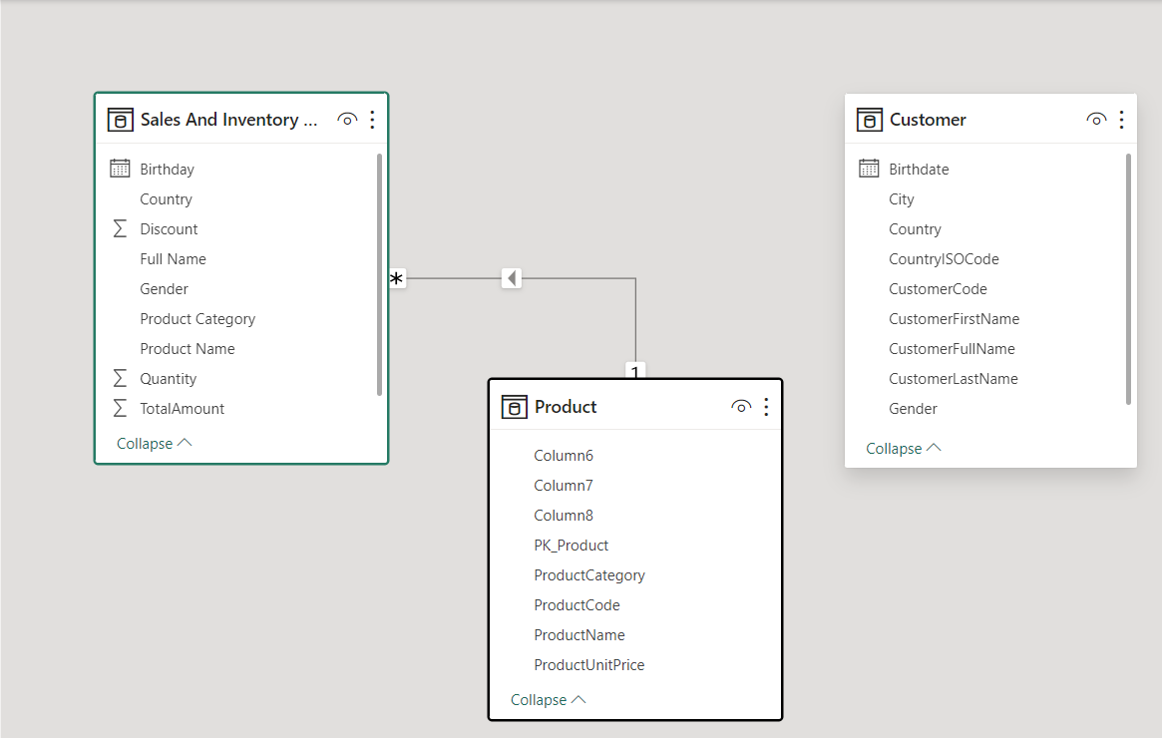

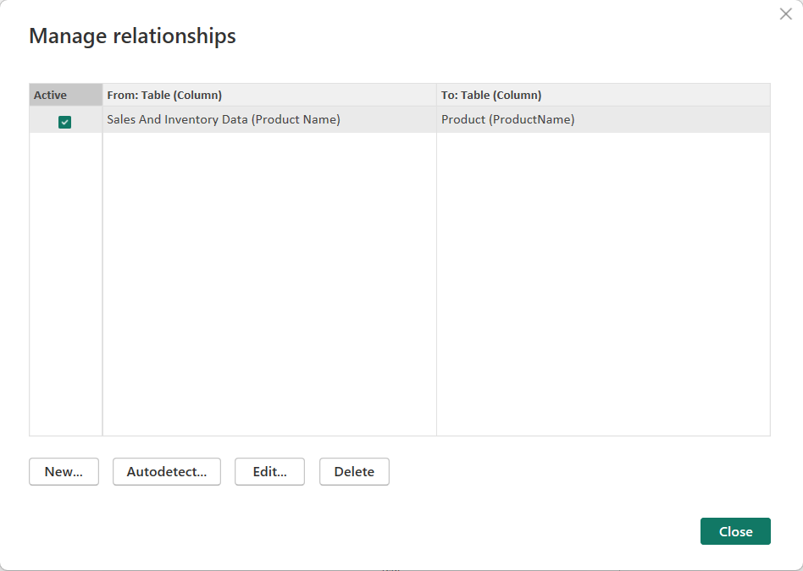

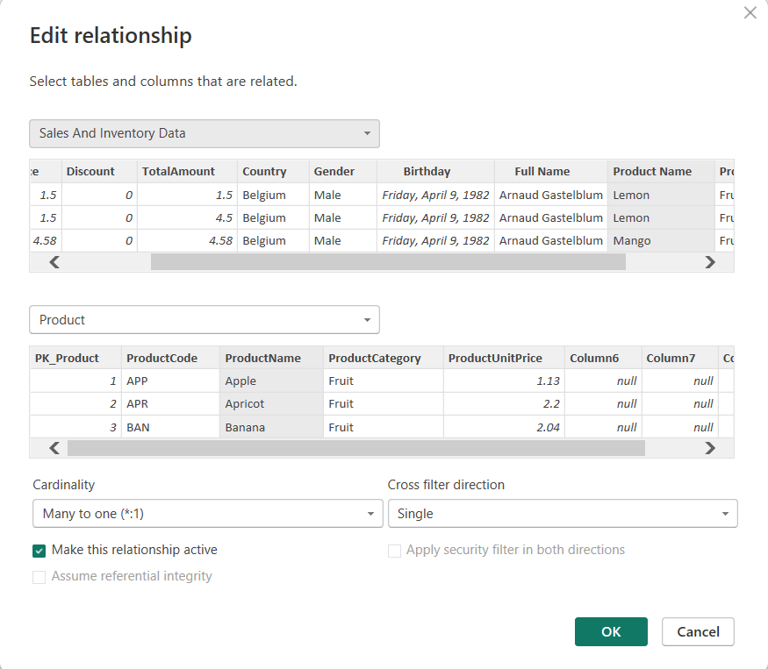

**Dashboard**

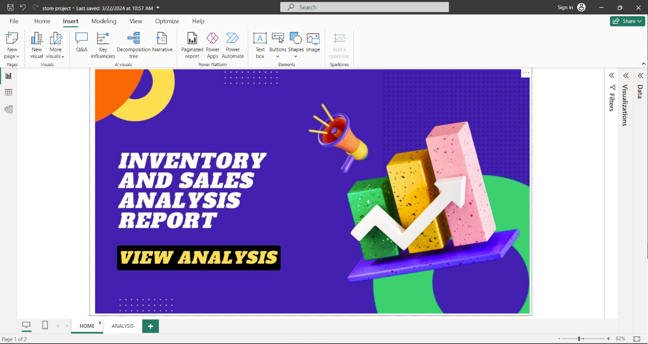

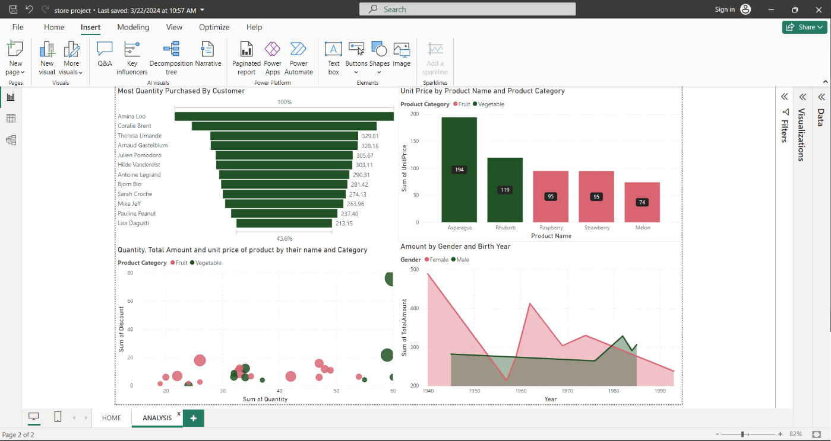

**CONCLUSION**

The project "Real-Time Sales Analysis" using Power BI has revolutionized the way sales data is analyzed in the retail sector. By harnessing real-time sales data, the project has provided invaluable insights into sales trends, customer purchasing behavior, and product performance. The interactive dashboards and reports have offered a comprehensive view of sales metrics, enabling businesses to identify key patterns, correlations, and opportunities for growth. This data-driven approach has not only enhanced the efficiency of sales analysis but also empowered businesses to make informed decisions regarding inventory management, marketing strategies, and customer engagement. The project underscores the significance of data visualization in transforming complex sales data into actionable insights, thereby driving business success and profitability.

**FUTURE SCOPE**

The future prospects of this project are promising, especially with the rapid advancements in data analytics and machine learning capabilities. By harnessing the power of Power BI's predictive analytics features, the project can evolve to forecast future market trends and customer behaviors based on historical data patterns. This predictive capability opens doors for the bank to proactively address customer needs and deliver personalized solutions. Moreover, the project's integration with diverse data sources can expand to encompass a broader spectrum of customer information, leading to a more comprehensive understanding of customer profiles and preferences. As data security and privacy remain paramount concerns, future iterations of the project should prioritize implementing robust data governance measures to ensure compliance with stringent data protection regulations and safeguard sensitive customer data. Additionally, exploring the integration of real-time data streams could further enhance the project's ability to provide timely and relevant insights, ultimately enhancing customer satisfaction and fostering long-term loyalty.

**REFERENCES**

<https://learn.microsoft.com/en-us/power-bi/create-reports/sample-sales-and-marketing>

**LINK**

**https://github.com/Adnan6678/Case-study-.git**